Definitions of Systems Engineering, Systems Engineering Knowledge, Life cycles, Life-cycle phases, logical steps of systems engineering, Frame works for systems engineering.

INTRODUCTION
While elements of systems engineering are recognizable in all major engineering ventures throughout history, the discipline is relatively young. The term was first used in Bell Telephone Laboratories in the 1940s in the context of taking a systems view when engineering networks.
Systems engineering provides the framework within which complex systems can be adequately defined, analyzed, specified, designed, manufactured, operated, supported, and ultimately retired.
The focus of systems engineering is on the system as a whole, and the maintenance of a strong interdisciplinary approach. Project management, quality assurance, integrated logistics support, and a wide variety of engineering disciplines are but a few of the many disciplines that are part of a coordinated systems engineering effort.
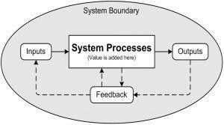

Definition
Systems engineering is the design, production, and maintenance of trustworthy systems within cost and time constraints
Other Definitions of System Engineering

Functional definition
    - Systems engineering is the art and science of creating a product or services ,based on phased effort that involve definition, design, development, production, and maintenance activities.

    - The resulting product or service is functional, reliable, of high quality, and trust worthy, and has been developed within cost and time constraints

Structure definition
Systems engineering is management technology to assist clients through the formulation, analysis, and interpretation of the impact of proposed policies, controls, or complete systems upon the need perspectives of the stakeholders to issue under consideration.

Purpose definition
The purpose of systems engineering is information and knowledge organization and management to assist clients who desire to develop policies for management, direction, control, and regulation activities relative to forecasting, planning, development, production, and operation of total systems to maintain overall quality, integration as related to performance, trustworthiness, reliability, and maintainability.

Levels of Systems Engineering
System engineering is an appropriate combination of the methods and tools of systems engineering, made possible through use of a suitable methodological process and systems management procedures. We distinguish three levels in system engineering as illustrated
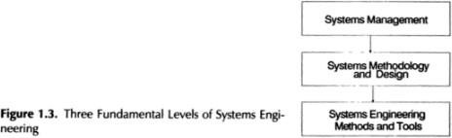

The third level, system management, focuses on high level issues: high level requirements as business needs and strategic needs, project management, quality management.
The second level, processes or methodologies, deals with all technical issues as systems requirements design methodologies standards.

The first level, methods and tools or technologies, covers the implementation issues concerning the methods to be used, the tools needed and the required
Technologies to respond to the various assets of requirements as reliability costs,maintainability, enabling technologies.
The purpose of systems engineering is to organize and manage information and knowledge. To assist clients who desire to develop policies for management, direction, control, and regulation activities relative to forecasting, planning, development, production and operation of total systems

Systems Engineering Benefits
- Systems engineering is about coping with complexity.
- Systems Engineering helps avoid omissions and invalid assumptions, helps to manage real world changing issues, and produce the most efficient, economic and robust solution.
- Systems engineering leads to a reduction in the technical risks associated with the product development.
- Risks are identified early and monitored throughout the process using a system of technical performance measures, and design reviews and audits.
- Design decisions can be traced back to the original user requirements and conflicting user requirements can be identified.

System Engineering Knowledge
The System Engineering Knowledge includes the following:
- Knowledge principles, which generally represent formal problem-solving approaches to knowledge, generally employed in new situations and/or unstructured environments
- Knowledge practices, which represent the accumulated wisdom and experiences that have led to the development of standard operating policies for well-structured problems
- Knowledge perspectives, which represent the view that is held relative to future directions and realities in the technological area under consideration
  - Clearly, one form of knowledge leads to another. Knowledge perspectives may create the incentive for research that leads to the discovery of new knowledge principles.
  - As knowledge principles emerge and are refined, they generally become

embedded in the form of knowledge practices.
  - Knowledge practices are generally the major influences of the systems that can be acquired or fielded.

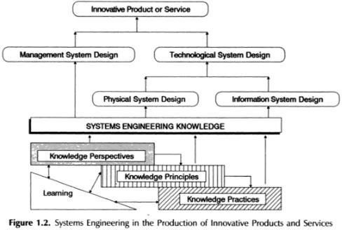

System Engineering Knowledge Types
- These knowledge types interact together as suggested in Figure, which illustrates how these knowledge types support one another.
- In a nonexclusive way, they each support one of the principal life cycles associated with systems engineering.
- Figure also illustrates a number of feedback loops that are associated with learning to enable continual improvement in performance

System Engineering Life cycle
Generally in system engineering, there are 3 Stages of life cycle
- Two Development Stage
- One Operational Stage

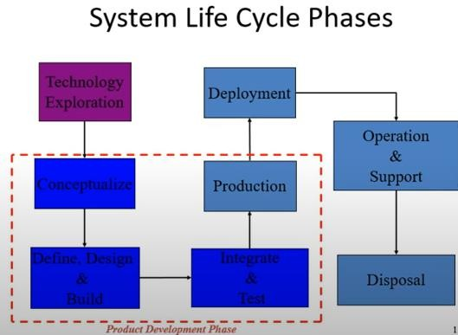

  - Conceptualize Stage- Comprises of analysis and planning. It’s the initial stage of idea generation for system formulation that will support the customer
  - Engineering Stage- this is a second stage where concept is converted into a valid product called a physical system that fulfills the requirement of a customer.
  - Field/Operational Stage- called as post development stage for production generation, deployment and support mechanism. Its otherwise called as acceptance stage.
Systems engineers are concerned with the appropriate definition, development, and deployment of the engineered systems. Each of these life- cycle models, and those that are out- growths of them, comprise these three phases in one way or another.

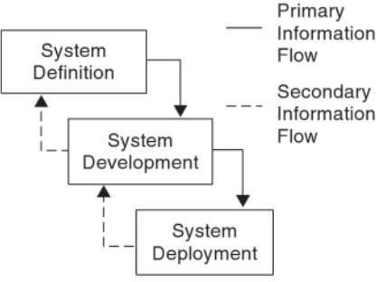

  - There are three different primary systems engineering life cycles for technology growth and change.
    - System planning and marketing Research, development, test, and evaluation (RDT&E)
    - System Acquisition and
    - Production
  - Each of these life cycles is generally needed, and each primarily involves the use of one of the three types of knowledge.
  - We discuss these life cycles briefly here and illustrate how and why they make major but nonexclusive use of knowledge principles practices, and perspectives.
  - There are a number of needed interactions across these life cycles for one particular realization of a system acquisition life cycle.
  - It is important that efforts across these three major systems engineering life cycles be integrated.
  - There are many illustrations of dramatically successful efforts in RDT&E, but where the overall results represent failure because of lack of consideration of planning or of the ultimate manufacturing needs of a product while it is in RDT&E

Issue Formulation
  - Problem definition involves isolating, quantifying, and clarifying the needs that create the issue at hand, and describing that set of environmental factors that constrain alterable for the system to be developed. In addition to identifying needs, we need to identify constraints, those facets that cannot be changed, and alterable, those facets that can be changed.

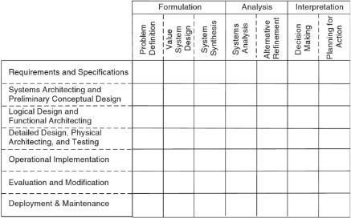
  - Value system design involves selection of the set of objectives or goals that guide the search for alternatives. Very importantly, value system design enables determination of the multidimensional attributes or decision criteria for selecting the most appropriate system. These are also known as objectives measures and represent, or may be transformed into, needed metrics for the evaluation of alternative courses of action in terms of their impact on the value system.
  - Systems synthesis involves searching for, or hypothesizing, a set of alternative courses of action or options. Each alternative must be described in sufficient detail to permit analysis of the impacts of implementation, and subsequent evaluation and interpretation with respect to the objectives. We also need to associate appropriate metrics with each identified alternative, and these may be called alternatives measures.

Analysis

- Systems analysis involves determining specific impacts or consequences that were specified as relevant by the value system. These impacts may relate to such important concerns as product quality, market, reliability, cost, and effectiveness or benefits. Modeling and simulation approaches are often used in systems analysis.
- Refinement of the alternatives refers to adjusting, sometimes by optimizing the system parameters for each alternative in order to meet system objectives, ideally

Interpretation
  - Decision assessment as a conscious activity will lead to decision making. This involves evaluating the impacts or consequences of the alternatives developed in analysis relative to the value system. This enables interpretation of these evaluations such that all alternatives can be compared relative to these values. One or more alternatives or courses of action can be selected for advancing to the next step.

  - Planning for action, or to implement the next phase, includes communicating the results of the effort to this point. It includes such pragmatic efforts as scheduling subsequent efforts, allocating resources to accomplish them, and setting up system management teams. If we are conducting a single- phase effort, this step would be the final one. More generally, it leads to a new phase of effort.

System Engineering Life cycle phases
We have identified a phased system engineering life cycle that consists of seven phases
    - Requirements and specifications identification
    - Preliminary conceptual design and system-level functional architecting
    - Logical design and physical architecture specification
    - Detailed design of the physical architecture and associated production and testing
    - Operational implementation of the resulting product or service system in the field
    - Evaluation and modification
    - Operational deployment

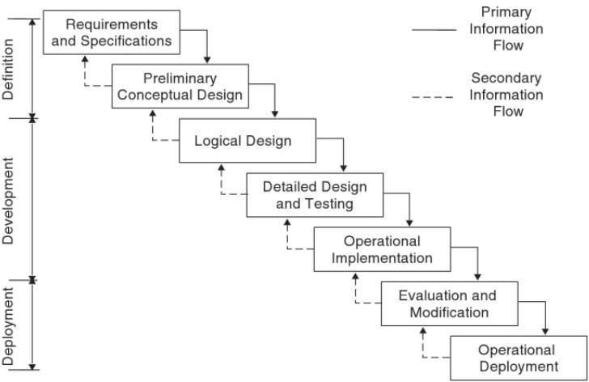
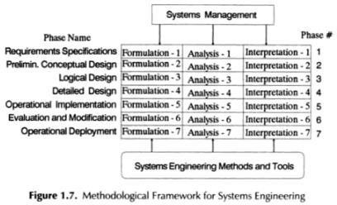

Life-cycle methodologies, or processes, for systems engineering
Systems engineering is the creative process through which products. Services or systems that are intended to be responsive to client needs and requirements are conceptualized or specified or defined, and ultimately developed and deployed. There are at least 15 primary assertions implied by this not uncommon definition of systems engineering, and they apply especially to the development of knowledge-intensive systems and software-intensive systems, as well as to more conventional hardware and physical systems.
Systems planning and marketing is the first strategic level effort in systems engineering. It results in the determination of whether or not a given organization should undertake the engineering of a given product or service. It also results in at least a preliminary determination of the amount of effort to be

devoted to RDT&E and the amount devoted to actual system acquisition or production.
Creation of an appropriate process or product line for RDT&E and one for acquisition is one result of systems planning and marketing. The initial systems planning and marketing efforts determine the extent to which RDT&E is a need; they also determine the acquisition process characteristics that are most appropriate. Systems Engineering Process (Logical Steps of System Engineering)

Systems Engineering Process (Logical Steps of System Engineering)
The Systems Engineering Process (SEP) is a comprehensive, iterative and recursive problem solving process, applied sequentially top-down by integrated teams. It transforms needs and requirements into a set of system product and process descriptions, generate information for decision makers, and provide input for the next level of development. The process is applied sequentially, one level at a time, adding additional detail and definition with each level of development. As shown by Figure, the process includes:
- inputs and outputs;
- requirements analysis;
- functional analysis and allocation;
- requirements loop;
- synthesis;
- design loop;
- verification; and
- system analysis and control

Inputs
The first step of the Systems Engineering Process is to analyse the process inputs. Inputs consist primarily of the customer’s needs, objectives, requirements and project constraints Inputs can include, but are not restricted to, missions, measures of effectiveness, environments, available technology base, output requirements from prior application of the systems engineering process, program decision requirements, and requirements based on corporate knowledge.

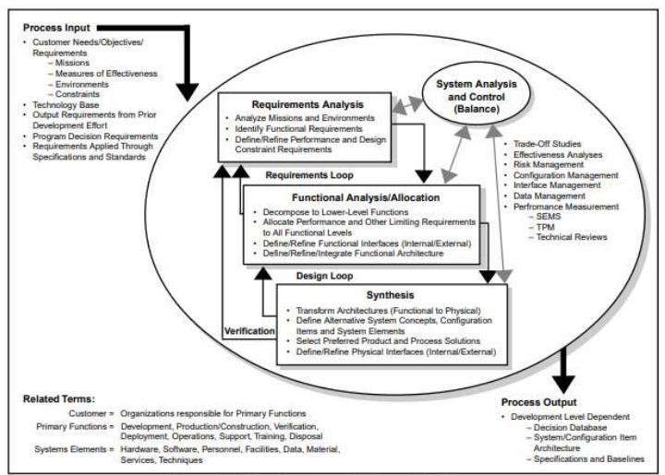

Requirements Analysis
Requirements analysis is used to develop functional and performance requirements; that is, customer requirements are translated into a set of requirements that define what the system must do and how well it must perform. The systems engineer must ensure that the requirements are understandable, unambiguous, comprehensive, complete, and concise
Requirements analysis must clarify and define functional requirements and design constraints. Functional requirements define quantity (how many), quality (how good), coverage (how far), time lines (when and how long), and availability (how often). Design constraints define those factors that limit design flexibility, such as: environmental conditions or limits; defense against internal or external threats; and contract, customer or regulatory standards.

Functional Analysis/Allocation
Functions are analyzed by decomposing higher level functions identified through requirements analysis into lower-level functions. The performance requirements associated with the higher level are allocated to lower functions. The result is a description of the product or item in terms of what it does logically and in terms of the performance required. This description is often called the functional architecture of the product or item.

Functional analysis and allocation allows for a better understanding of what the system has to do, in what ways it can do it, and to some extent, the priorities and conflicts associated with lower-level functions.
It provides information essential to optimizing physical solutions. Key tools in functional analysis and allocation are Functional Flow Block Diagrams, Time Line Analysis, and the Requirements Allocation Sheet.

Requirements Loop
Performance of the functional analysis and allocation results in a better understanding of the requirements and should prompt reconsideration of the requirements analysis. Each function identified should be traceable back to a requirement. This iterative process of revisiting requirements analysis as a result.

Design Synthesis
Design synthesis is the process of defining the product or item in terms of the physical and software elements which together make up and define the item. The result is often referred to as the physical architecture. Each part must meet at least one functional requirement, and any part may support many functions. The physical architecture is the basic structure for generating the specifications and baselines.

Design Loop
Similar to the requirements loop described above, the design loop is the process of revisiting the functional architecture to verify that the physical design synthesized can perform the required functions at required levels of performance. The design loop permits reconsideration of how the system will perform its mission, and this helps optimize the synthesized design.

Verification
For each application of the system engineering process, the solution will be compared to the requirements. This part of the process is called the verification loop, or more commonly, Verification. Each requirement at each level of development must be verifiable. Baseline documentation developed during the systems engineering process must establish the method of verification for each requirement Appropriate methods of verification include examination, demonstration, analysis (including modeling and simulation), and testing.

Formal test and evaluation (both developmental and operational) are important contributors to the verification of systems.

Systems Analysis and Control Systems
Analysis and Control include technical management activities required to measure progress, evaluate and select alternatives, and document data and decisions. These activities apply to all steps of the systems engineering process. System analysis activities include trade-off studies, effectiveness analyses, and design analyses.
They evaluate alternative approaches to satisfy technical requirements and program objectives, and provide a rigorous quantitative basis for selecting performance, functional, and design requirements. Tools used to provide input to analysis activities include modelling, simulation, experimentation, and test.
Control activities include risk management, configuration management, data management, and performance-based progress measurement including event- based scheduling, Technical Performance Measurement (TPM), and technical reviews.

The purpose of Systems Analysis and Control is to ensure that:
- Solution alternative decisions are made only after evaluating the impact on system effectiveness, life cycle resources, risk, and customer requirements,
- Technical decisions and specification requirements are based on systems engineering outputs,
- Traceability from systems engineering process inputs to outputs is maintained,
- Schedules for development and delivery are mutually supportive,
- Required technical disciplines are integrated into the systems engineering effort,
- Impacts of customer requirements on resulting functional and performance requirements are examined for validity, consistency, desirability, and attainability, and,
- Product and process design requirements are directly traceable to the functional and performance requirements they were designed to fulfill, and vice versa.

Systems Engineering Process Output
Process output is dependent on the level of development. It will include the decision database, the system or configuration item architecture, and the baselines, including specifications, appropriate to the phase of development. In general, it is any data that describes or controls the product configuration or the processes necessary to develop that product

Systems Engineering Framework
Generally, when developing complex systems two main problems arise:
- The need to address all the aspects of the system of interest (to design and develop).
- The need to share the knowledge between people involved in the process. To match these needs, model-based system engineering is necessary. However, the need of a model-based approach induces new issues:
  - Trustworthiness: how close the model is to the reality?
  - Understandability: is the model perceived and understood the same way by people?
  - Usefulness: does the model help to get the desired results?
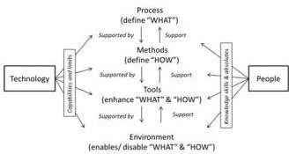
Besides, with the emergence of model-based system engineering methodologies, a framework has been proposed for better understanding. The terminologies are:
  - Process: sequence of tasks aiming to achieve a particular objective. Process defines what is to be done without defining how each activity has to be performed.

  - Method: specifies how to perform each task.
  - Tool: helps to accomplish of how. It usually supports a language that helps applying the method.
  - Methodology: is defined “as a collection of related processes, methods, and tools”. In model driven context, MBSE can be defined as a collection of process, tools and methods help to harmonize system engineering discipline.
  - Environment: consists of external conditions, systems, or factors that have an influence on systems, actors. The purpose of environment is to put in practice the use of tools and methods of a project.
The main aim of the framework is to provide a simple construct within which the systems engineering discipline can be understood and implemented. The framework illustrates the relationship of the three main elements of systems engineering processes, systems engineering management, and systems engineering tools, and places them in context with related disciplines such as traditional engineering disciplines, project management, integrated logistics support, and quality assurance
we present generic process tools such as requirements breakdown structures (RBS), functional flow block diagrams (FFBD), work breakdown structures (WBS), trade-off analyses, and prototyping and simulation as examples of tools that may be applied to the systems engineering process effort.
There are several frameworks commonly used in systems engineering to help organize and guide the development of complex systems.

Model Framework
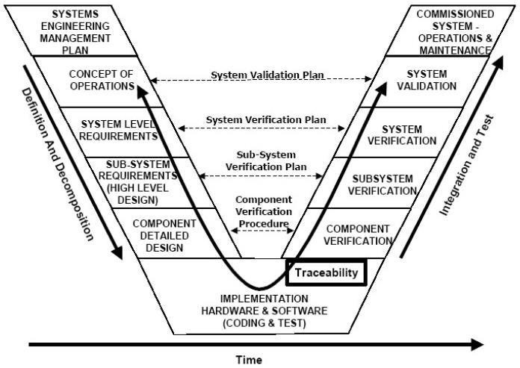
  - It representing the flow of activities from requirements gathering at the top left, through design, implementation, testing, and validation, and finally to system deployment and maintenance at the top right.
  - It emphasizes the importance of early involvement of stakeholders and continuous verification and validation throughout the system development life cycle.
  - It defines a set of processes, activities, and tasks that cover the entire system life cycle, from concept to disposal.
  - Its core involves a sequential progression of plans, specifications, and products that are baselined and put under configuration management. The Vee Model provides guidance for the planning and realization of projects. The following objectives are intended to be achieved by a project execution:
- Minimization of Project Risks: The Vee Model improves project transparency and project control by specifying standardized approaches and describing the corresponding results and responsible roles. It permits an early recognition of planning deviations and risks and improves process management, thus reducing the project risk.

- Improvement and Guarantee of Quality: As a standardized process model, the Vee Model ensures that the results to be provided are complete and have the desired quality. Defined interim results can be checked at an early stage. Uniform product contents will improve readability, understandability and verifiability.
- Reduction of Total Cost over the Entire Project and System Life Cycle: The effort for the development, production, operation and maintenance of a system can be calculated, estimated and controlled in a transparent manner by applying a standardized process model. The results obtained are uniform and easily retraced. This reduces the acquirers’ dependency on the supplier and the effort for subsequent activities and projects.
- Improvement of Communication between all Stakeholders: The standardized and uniform description of all relevant elements and terms is the basis for the mutual understanding between all stakeholders. Thus, the frictional loss between user, acquirer, supplier and developer is reduced.

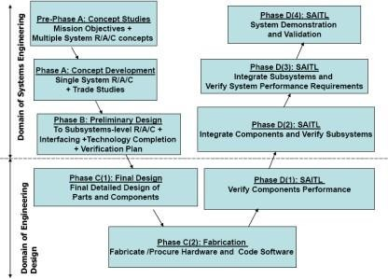

The Vee is a process model that can be tailored for specific types of programs/enterprises.
- In each box are the objectives of the Phase
- For each box on left leg apply the 13 systems engineering functions to achieve the objectives

- Process - Move Down Left Leg completing each and every Phase sequentially, then move up the right leg. The right leg is concerned with physical realization (“implementation”).
- Pre-Phase A (Concept Studies) - Produce a Broad Spectrum of Ideas (“feasible alternatives”)
- Phase A (Concept and Technology Development) - Through trade studies achieve a Single System “Architecture” with requirements
- Phase B (Produce a Preliminary Design) - Establish a preliminary design, with subsystem requirements, interfaces, and with technology issues resolved.
- Phase C (Detailed Design) – detailed design and drawings, purchase or manufacture parts and components, code software.
- Phase D (System Assembly, Integration, Test and Launch) - Assemble subsystems, integrate subsystems to create systems, test to verify and validate performance, and deploy the system.
- Left Leg: Formulation Phases are concerned with Decomposition and Definition. Right Leg: Implementation Phases are concerned with Integration and Verification
- Decomposition and definition is logically “tearing down” the system to eventually reveal the complete system architectural design.
- Proceeding up the right leg, Integration and Verification is equivalent to “building up” the physical system and testing - from the component level to a completed functioning and tested system.
- Boxes on the same horizontal level are the same product hierarchy level. Requirements created on the left side “translate” horizontally to requirements for testing during implementation.
- The Vee chart is divided by a horizontal dashed line that reveals the responsibility boundary between the systems engineering tasks and the tasks typically performed by the design engineering teams applying the EDP to create a detailed design of a subsystem.

